**Game Description:**

Sonic: Speed Nexus is a fast-paced platformer where players control **Sonic**, **Tails**, and **Knuckles** to race through futuristic worlds, battle robots, and stop **Dr. Eggman**. As the game progresses, **difficulty rises** and characters unlock new abilities to tackle tougher enemies, faster levels, and intense boss fights.

**Screenshots:**

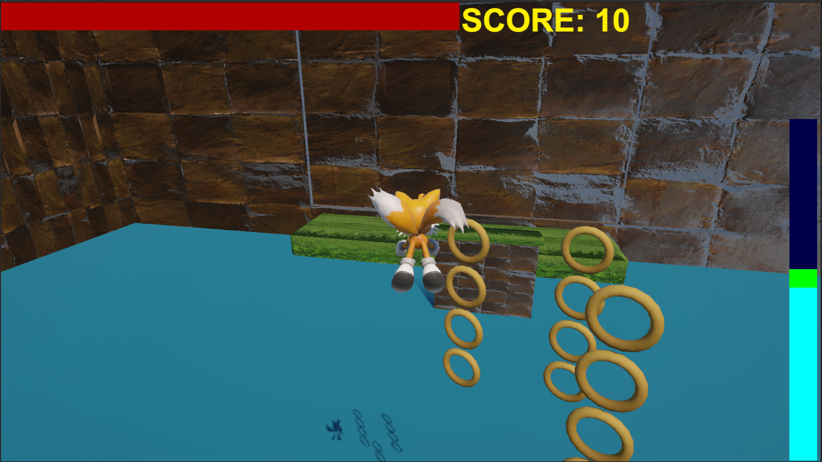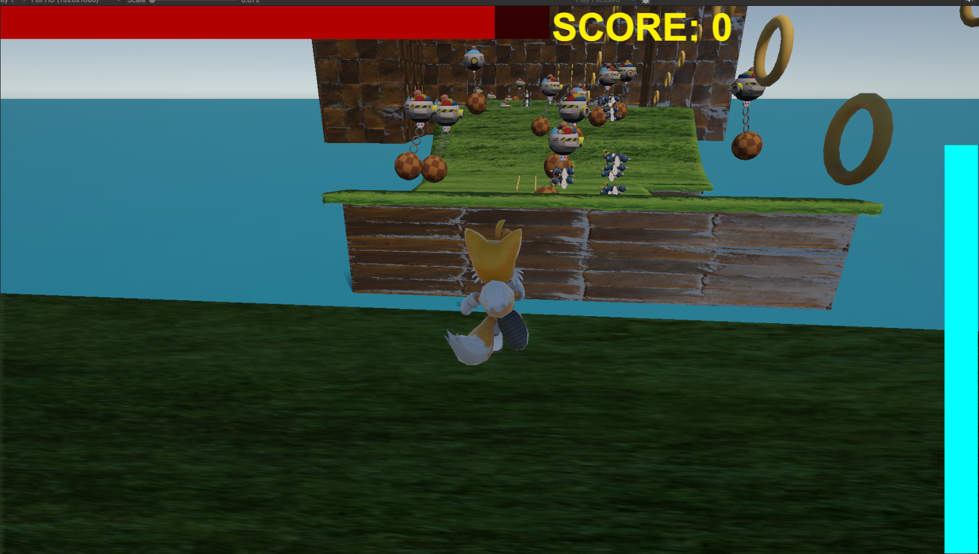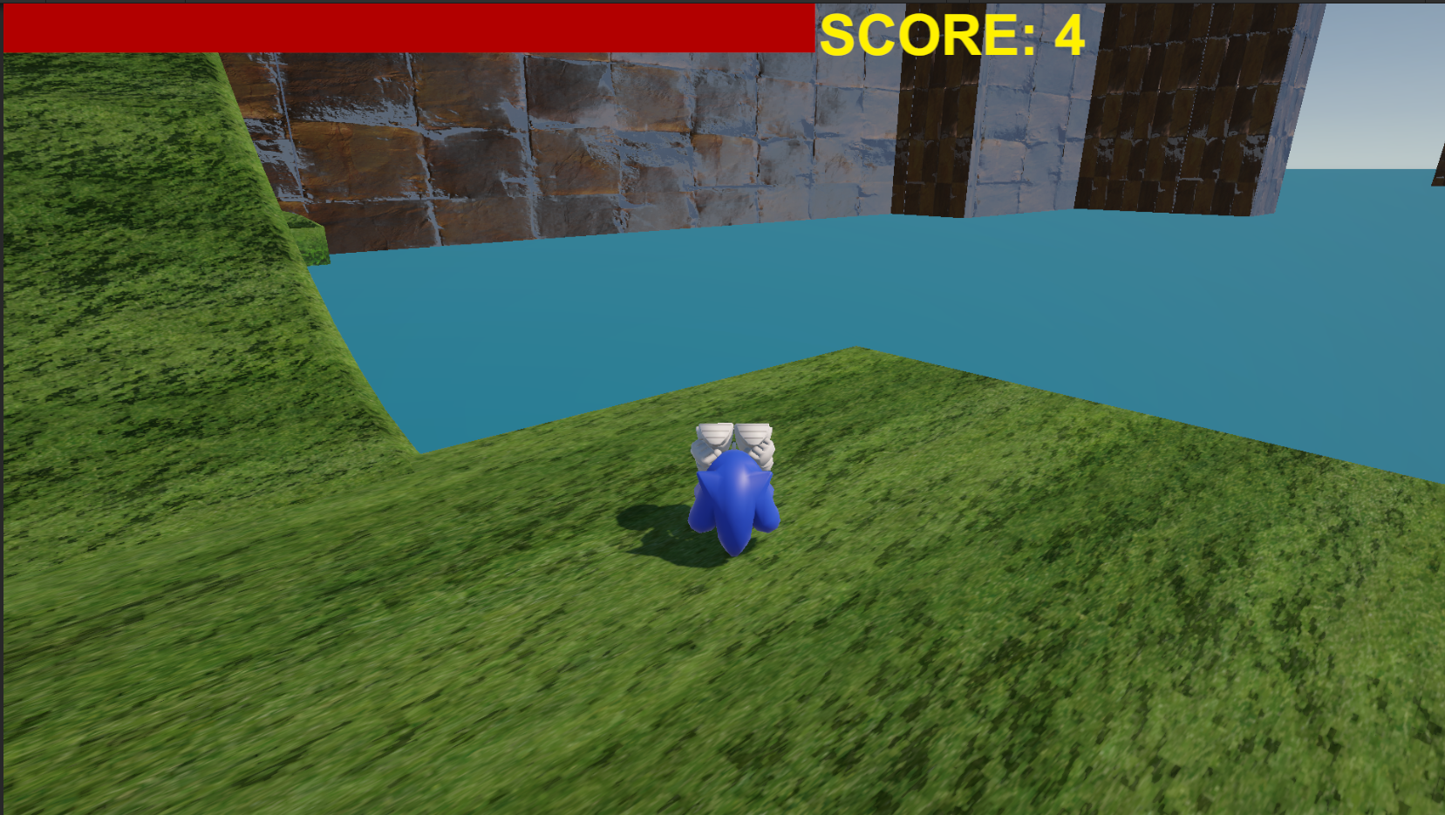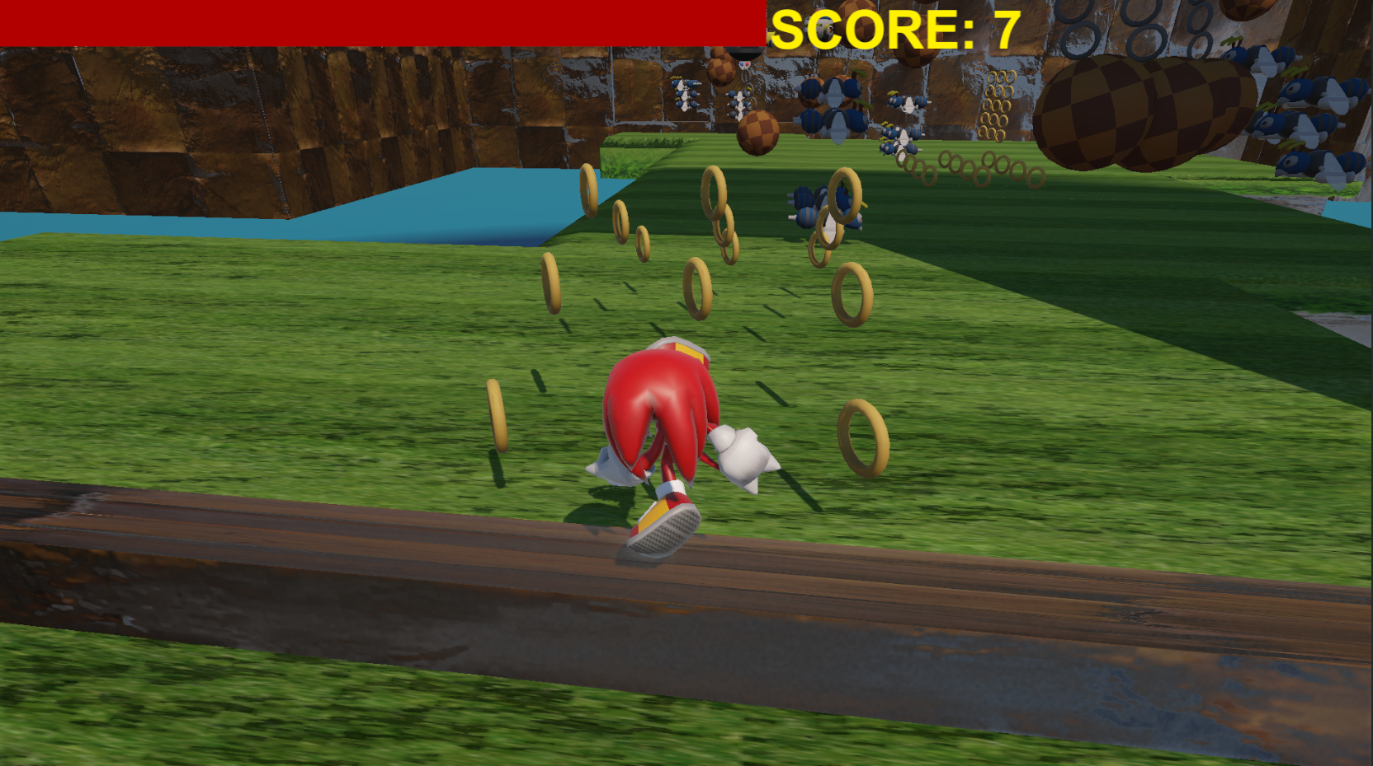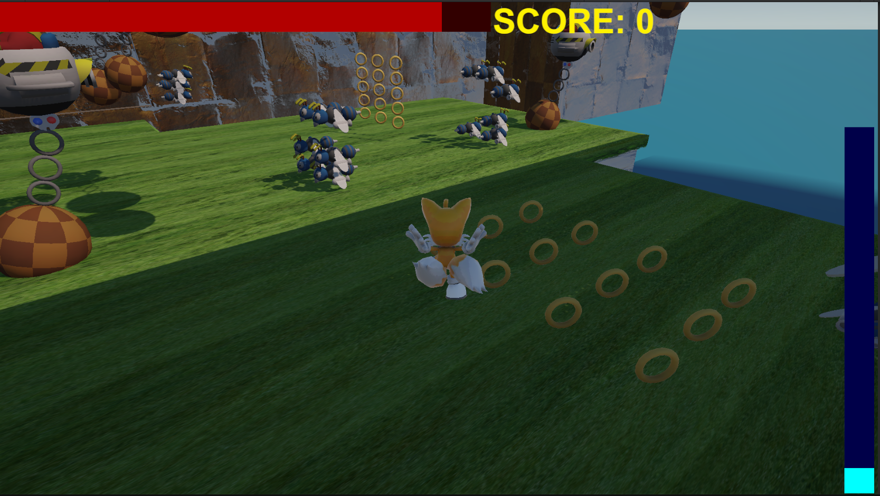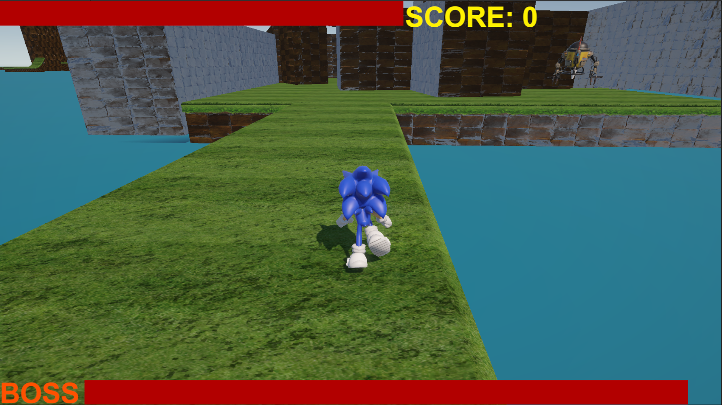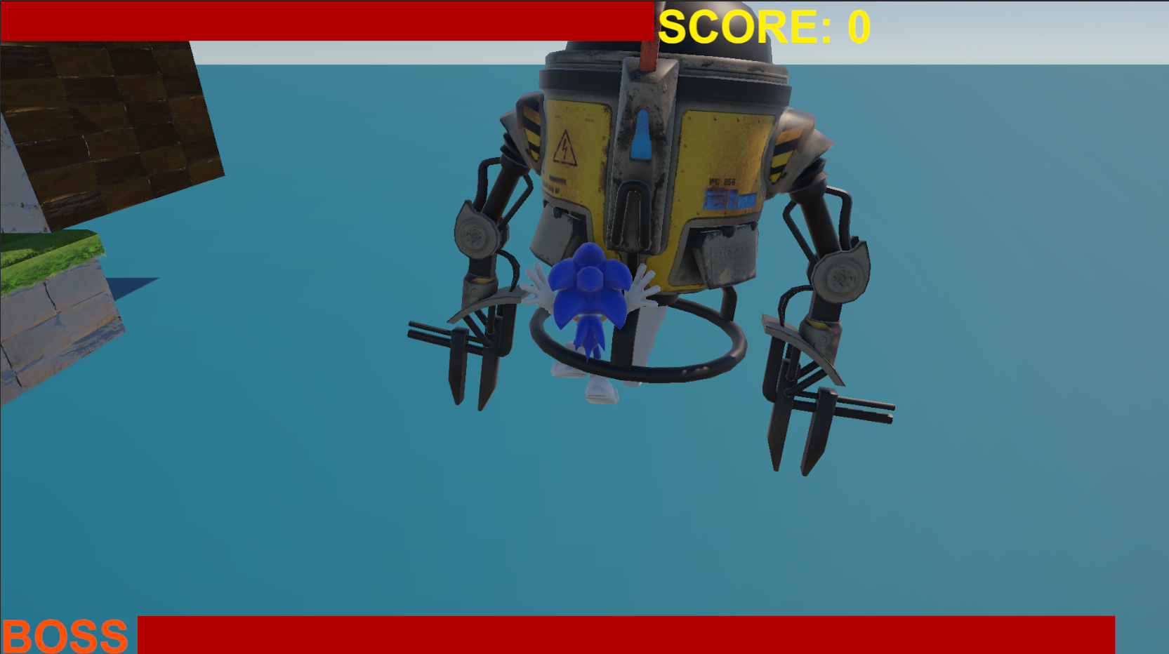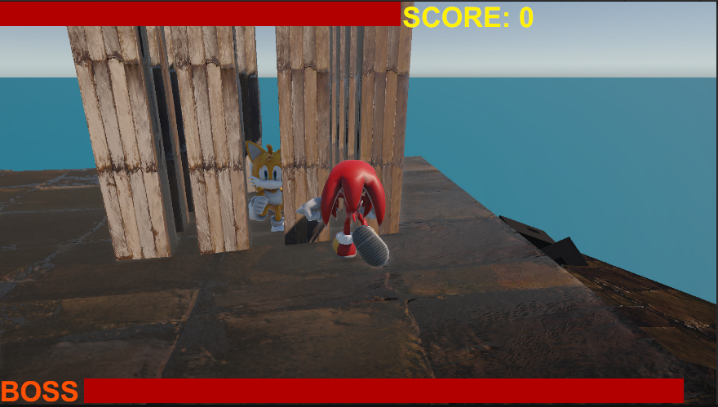

Main Menu

Player can adjust the difficuly of the gameplay

Tails character can fly according to it’s stamina on the right side of the screen

Different kinds of villains on the way

Game over if the health reaches zero

Sonic's special power is rolling, which allows him to increase his speed.

Knuckles' special power allow him to break walls just by touching them.

Different random amount of coins with specific formations

The boss fight starts by bypassing a maze with a drone chasing the character

Dr. Eggman imprisoned Tails!

The drone throws the character in the ocean if it catches the character

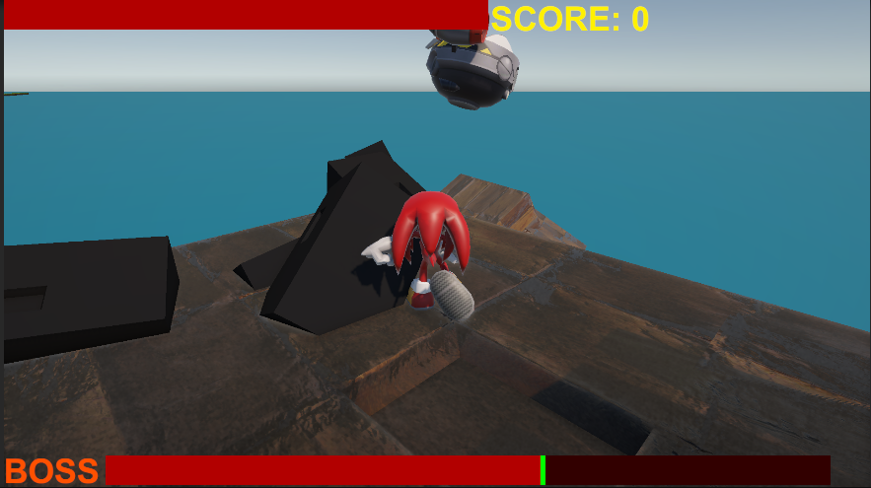**User Manual**

Defeating Dr. Eggman by throwing stones at him by Knuckles

### Game Controls:

* **Move Character:** Use the **Arrow Keys** or **W, A, S, D**
* **Jump:** Press **Spacebar**
* **Switch Character:** Press **X**
* **Use Special Power:** Press **Z**

### Gameplay Instructions

The game begins with **Sonic** as the default character. Players can switch between **Sonic**, **Tails**, and **Knuckles** by pressing the **X** key. Each character has a unique special power, activated by pressing **Z**.

Your goal is to **avoid enemies**, navigate through challenging levels, and ultimately **defeat Dr. Eggman** in an intense boss battle.